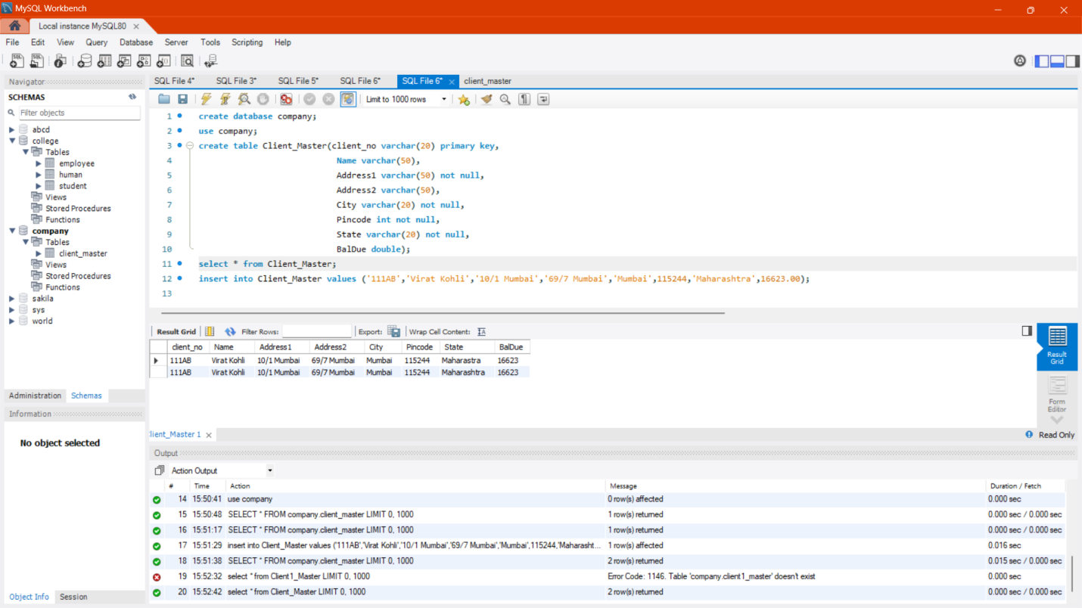

create database company;

use company;

create table Client_Master(client_no varchar(20) primary key,

Name varchar(50),

Address1 varchar(50) not null,

Address2 varchar(50),

City varchar(20) not null,

Pincode int not null,

State varchar(20) not null,

BalDue double);

select * from Client_Master;

insert into Client_Master values ('111AB','Virat Kohli','10/1 Mumbai','69/7 Mumbai','Mumbai',115244,'Maharashtra',16623.00);